Craig ELlrod

senior cloud security architect

Deploying Armor Security for Containers

Dockerhub - Linux

Table of Contents

Introduction 2

Prerequisites 2

How it works 2

Step-by-Step – Up and running 4

Step 1 – Create a Docker Hub repository. 4

Step 2 – Login to Docker Hub from the command line. 5

Step 3 - Create a docker image. 5

Step 4 - List your docker image. 7

Step 5 - Tag your docker image. 7

Step 6 - Push your docker image up to the repository. 7

Step 7 – Confirm the image was pushed into the repository. 8

Step 8 – Connect the Armor Management Portal to the Docker Hub Repository. 8

Step 9 – Create a New Registry entry. 9

Step 10 – Download and run a New Sensor. 12

Step-by-Step – Remediation 14

Step 11 – Vulnerabilities 14

Appendix – A – Installing the ARMOR sensor on a Docker Host, inside a Linux VM in Virtual Box 16

a. Download the sensor 16

b. Untar the sensor 16

c. Export the environment variable 17

d. Create the directory 17

e. Change the permissions 17

f. Run the sensor 17

Appendix – B – Useful docker commands 18

a. login to your docker host 18

b. Who are you 18

c. List images 18

d. Show all running containers 18

e. Stop all running containers 19

f. Delete all stopped containers 19

g. Remove all container images 19

# Introduction

This ARMOR Defense field guide will present a step-by-step method to deploy the Armor Security solution for Dockerhub.

## Prerequisites

A Docker Hub account.

<https://hub.docker.com>.

A Docker Hub Repository.

<https://docs.docker.com/docker-hub/repos/>

A Docker host – For example Linux Ubuntu – running as a virtual machine in VirtualBox, with Docker installed.

<https://virtualbox.org>

<https://ubuntu.com/download>

<https://docs.docker.com/engine/install/ubuntu/>

Note: A Docker Hub step-by-step tutorial is located here.

<https://docs.docker.com/docker-hub/>

Note2: Armor Anywhere for Containers documentation is located here.

<https://docs.armor.com/display/KBSS/For+Containers>

## How it works

Installing the Armor Container Registry Scanner for Docker Hub involves these simple steps.

The ARMOR connector, provides the Authentication and Authorization for Armor Management Portal to access your DockerHub Registry.

The ARMOR sensor runs as a container inside of a Docker Host and scans the registry for vulnerabilities. Please note, this sensor is only designed to scan your dockerhub registry for vulnerabilities. It does not scan any container images running on the docker host. An additional sensor that will scan for real-time vulnerabilities and threats will be coming in a future release and will require additional instrumentation to deploy.

Note: The Armor Container Registry Scanner for Docker Hub is dependent upon the use of Tags. There are many articles out on the ‘net’ regarding ‘container tagging best practices’.

* Create (or use an existing one) Docker Hub repository.
* Create your docker image, tag it and push it to the repository.
* Connect Armor to the container registry. (ARMOR Connector)
* Download, Install and run a container sensor to scan your docker registry. (ARMOR sensor)

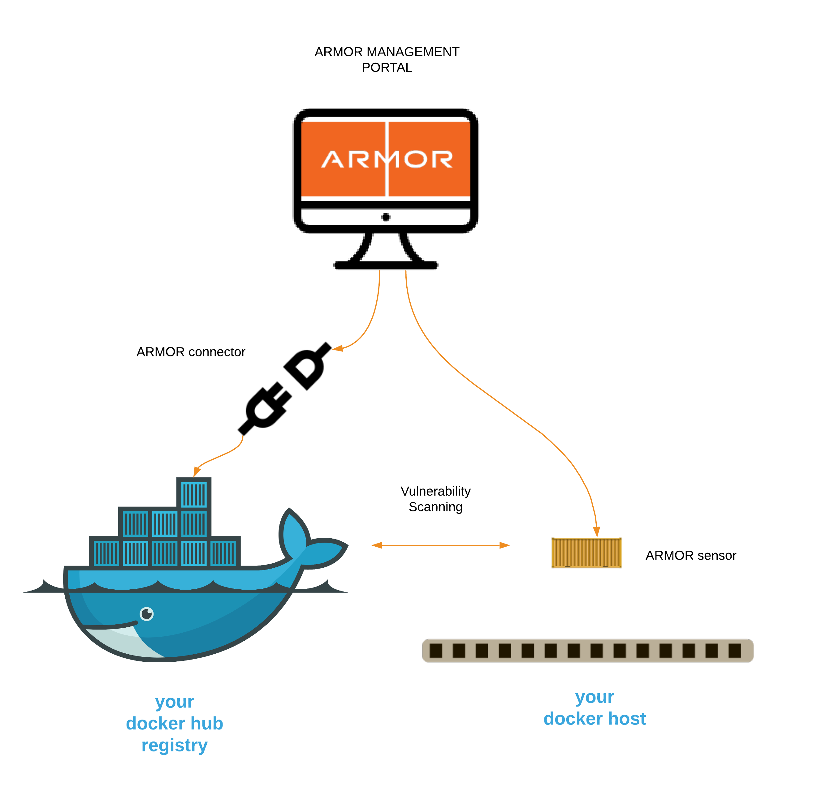

# Step-by-Step – Up and running

## Step 1 – Create a Docker Hub repository.

The format required for a Docker Hub repository are as follows:

<organization name>/<repository>:<tag>

For our example:

You will use a web browser to create your docker hub account and first repository, called ‘hello-world’.

Organization name = armorcloudsecurity

Repository = hello-world

Tag = latest

Note: The repository name you create is generally equated to the name of the application container, for example the repository for the Official docker ‘hello-world’ container is actually called the “hello-world” repository, which can be found at <https://hub.docker.com/_/hello-world>. There is no organization in the URL, as specified by the “/_/” because it is an official Docker repository.

When you create your repository, it will container your organization name, for example <https://hub.docker.com/armorcloudsecurity/hello-world>.

Note: When you create a Docker Hub repository, the URL of the Docker Hub Registry is https://registry-1.docker.io

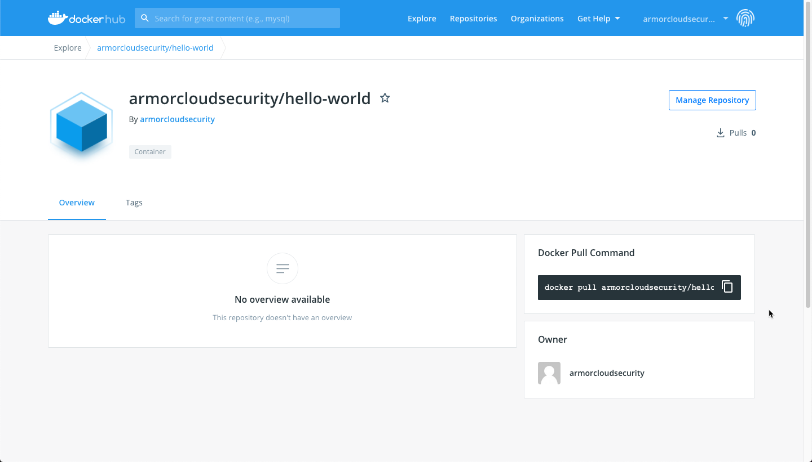

## Step 2 – Login to Docker Hub from the command line.

Sample **input** / output – docker login:

﻿$ **docker login --username=armorcloudsecurity**

**Password:**

WARNING! Your password will be stored unencrypted in /root/.docker/config.json.

Configure a credential helper to remove this warning. See

https://docs.docker.com/engine/reference/commandline/login/#credentials-store

Login Succeeded

$

## Step 3 - Create a docker image.

If you don’t have a docker image, you can use the following.

<https://hub.docker.com/_/hello-world>

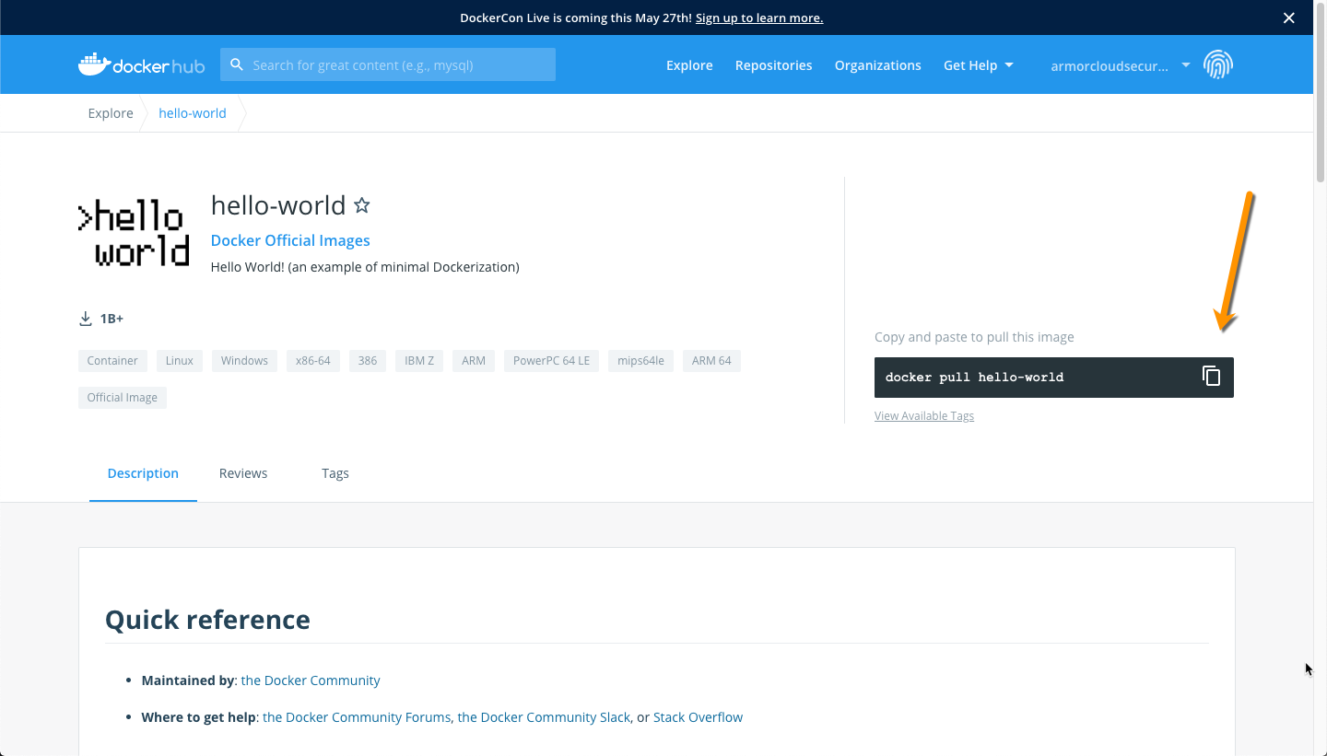

Copy the pull command and paste it into a terminal window on the Ubuntu machine.

Sample **input** / output - docker pull:

﻿$ **docker pull hello-world**

Using default tag: latest

latest: Pulling from library/hello-world

Digest: sha256:f2266cbfc127c960fd30e76b7c792dc23b588c0db76233517e1891a4e357d519

Status: Image is up to date for hello-world:latest

docker.io/library/hello-world:latest  
$

Sample **input** / output – docker run:

﻿$ **docker run hello-world**

Hello from Docker!

This message shows that your installation appears to be working correctly.

To generate this message, Docker took the following steps:

1. The Docker client contacted the Docker daemon.

2. The Docker daemon pulled the "hello-world" image from the Docker Hub.

(amd64)

3. The Docker daemon created a new container from that image which runs the

executable that produces the output you are currently reading.

4. The Docker daemon streamed that output to the Docker client, which sent it to your terminal.

To try something more ambitious, you can run an Ubuntu container with:

$ docker run -it ubuntu bash

Share images, automate workflows, and more with a free Docker ID:

<https://hub.docker.com/>

For more examples and ideas, visit:

<https://docs.docker.com/get-started/>

$

## Step 4 - List your docker image.

Sample **input** / output – docker list images:

﻿$ **docker images**

REPOSITORY TAG IMAGE ID CREATED SIZE

hello-world latest d1165f221234 2 months ago 13.3kB

$

If you don’t create a new tag, docker will default to using the “latest” tag.

## Step 5 - Tag your docker image.

Use the Image ID from the previous command, to apply a tag to the image.

**docker tag d1165f221234 armorcloudsecurity/hello-world:latest**

Validate the tag was assigned to the docker image.

﻿$ **docker images**

REPOSITORY TAG IMAGE ID CREATED SIZE

﻿hello-world latest d1165f221234 2 months ago 13.3kB

armorcloudsecurity/hello-world latest d1165f221234 2 months ago 13.3kB$

## Step 6 - Push your docker image up to the repository.

﻿$ **docker push armorcloudsecurity/hello-world:latest**

﻿The push refers to repository [docker.io/armorcloudsecurity/hello-world]

f22b99068db9: Mounted from library/hello-world

armordefense: digest: sha256:1b26826f602946860c279fce658f31050cff2c596583af237d971f4629b57792 size: 525

$

## Step 7 – Confirm the image was pushed into the repository.

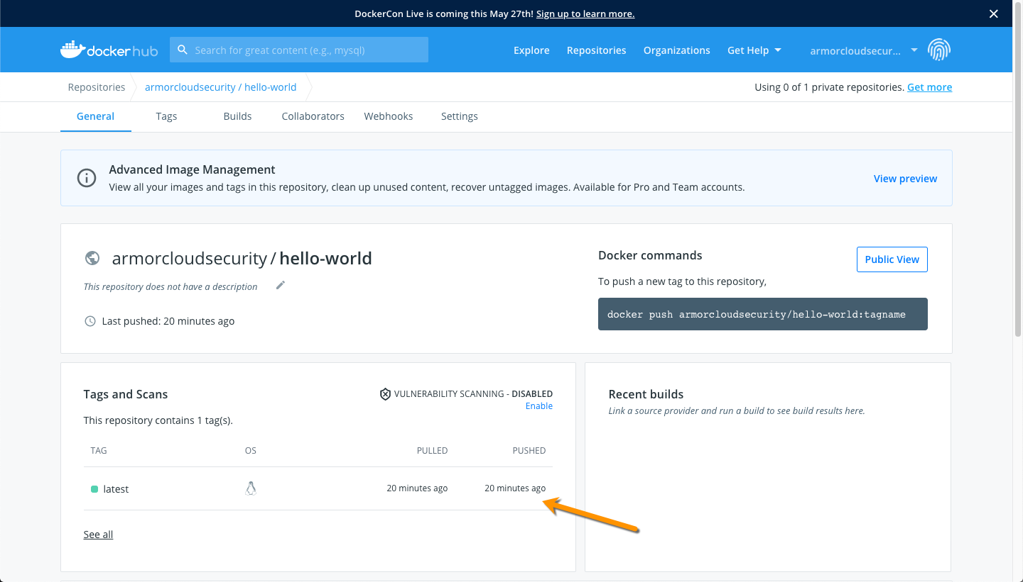

## Step 8 – Connect the Armor Management Portal to the Docker Hub Repository.

Log into the Armor Management Portal and navigate to Security 🡪 Container Security. Click on Connectors 🡪 Docker. Give the connector a name and enter your Docker Hub login credentials.

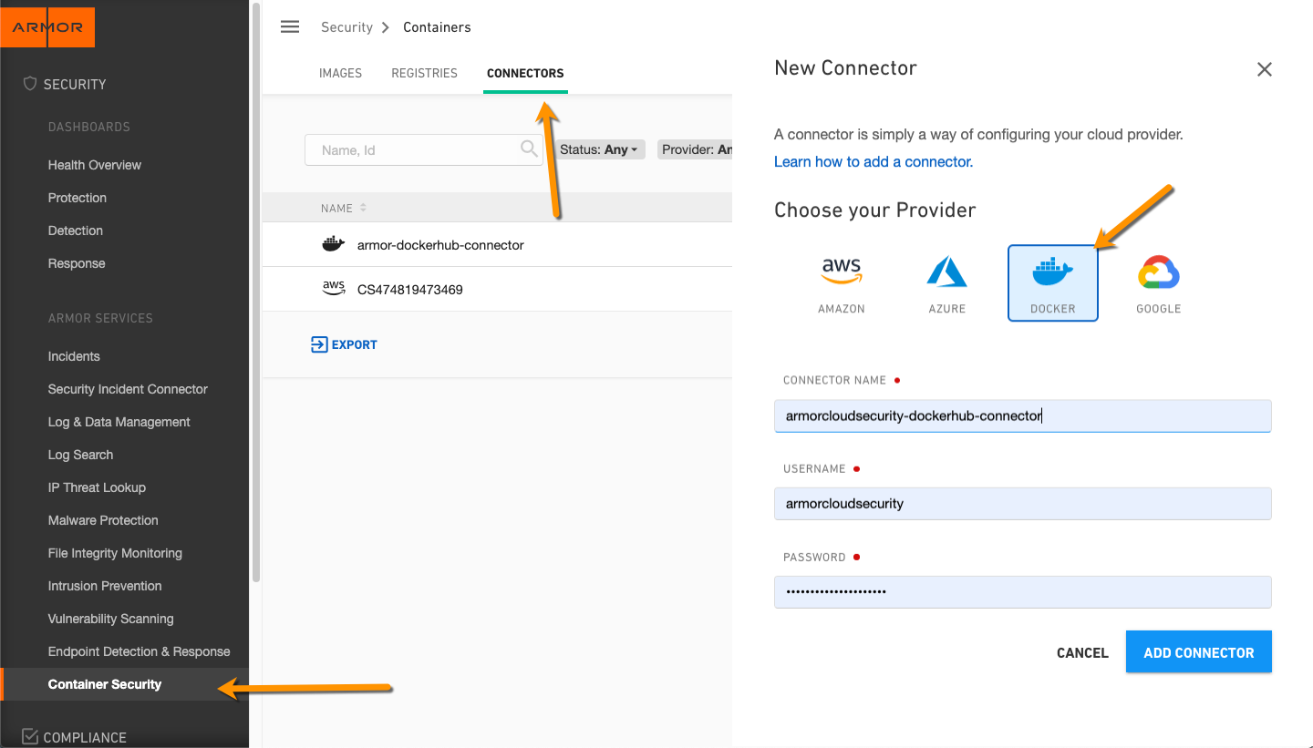

## Step 9 – Create a New Registry entry.

Select New Registry to add your New or Existing Docker Hub Registry.

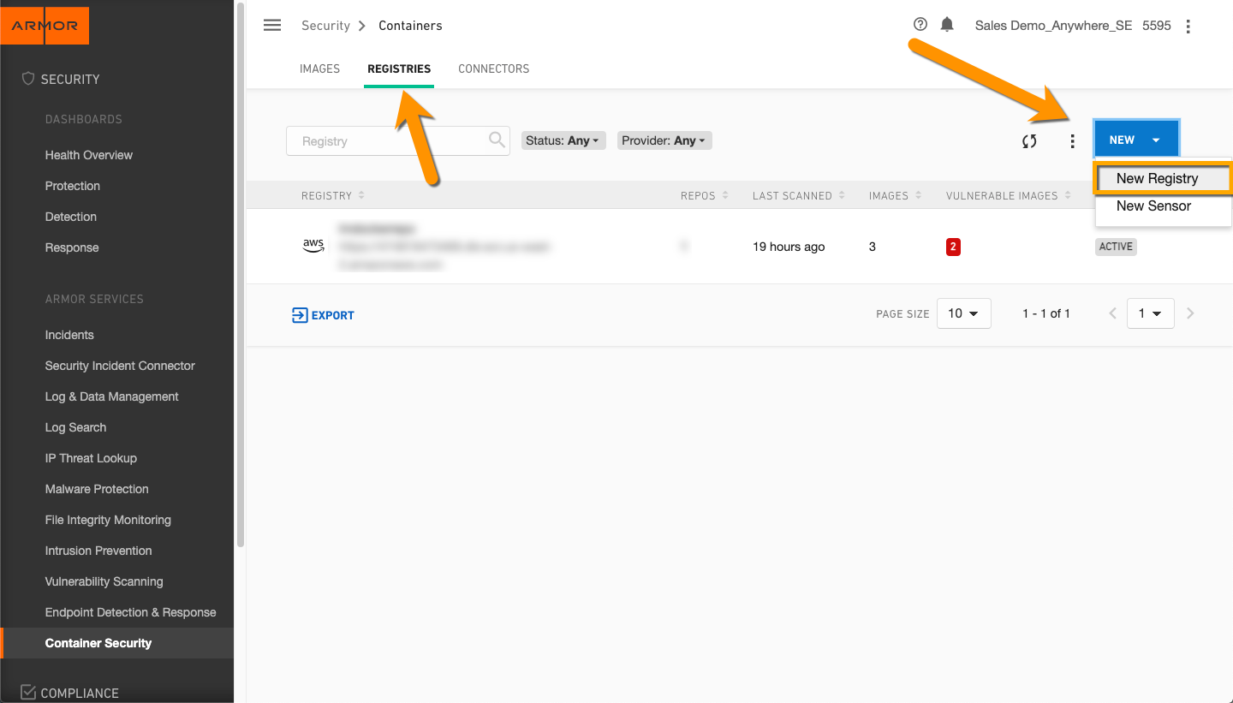

Select Docker.

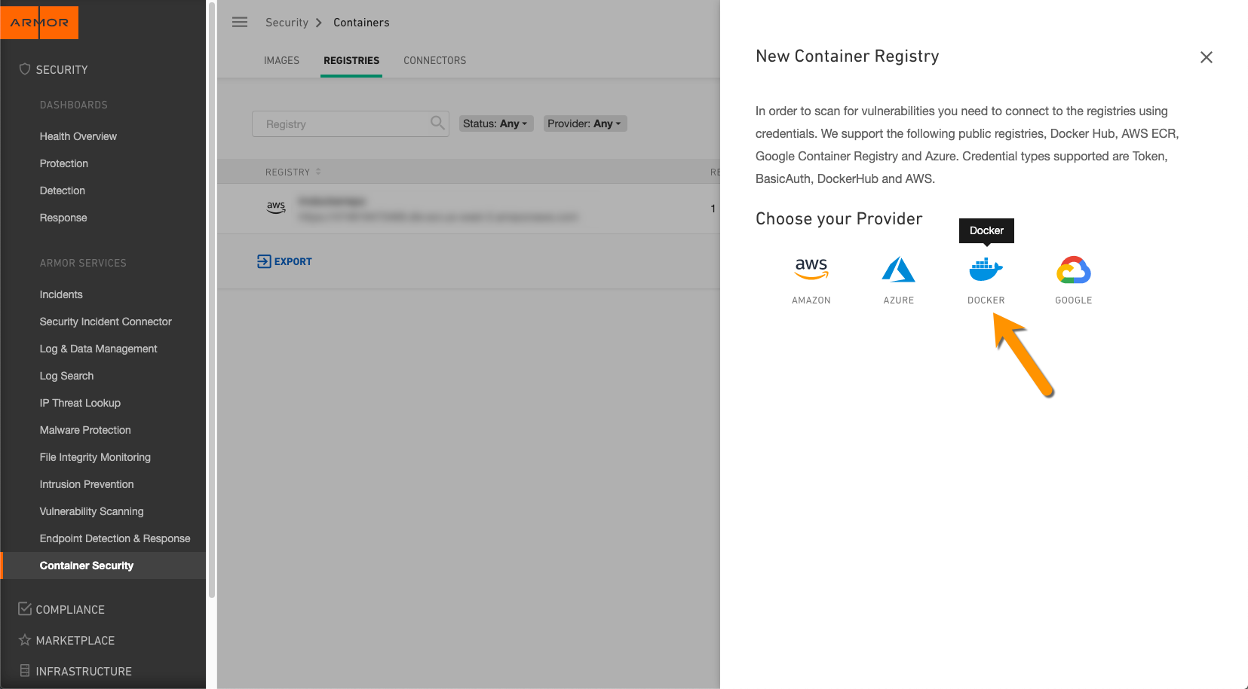

Enter in your Docker Hub repository details.

The Registry Name is an arbitrary name that you assign to this entry in the Armor Management Portal, and it appears only in AMP. Select the connector created in the previous step. Enter your Org name, Repository Name and Tag.

Note: You must click on Add to add this repo before adding it to the registry. You can add multiple repositories and tags at this time.

Add the Registry entry.

Note: You must “Add” the repository and tag before Add Registry will be click-able. Also, you can add multiple repositories and tags during this session.

Soon after the registry status will become “Active”.

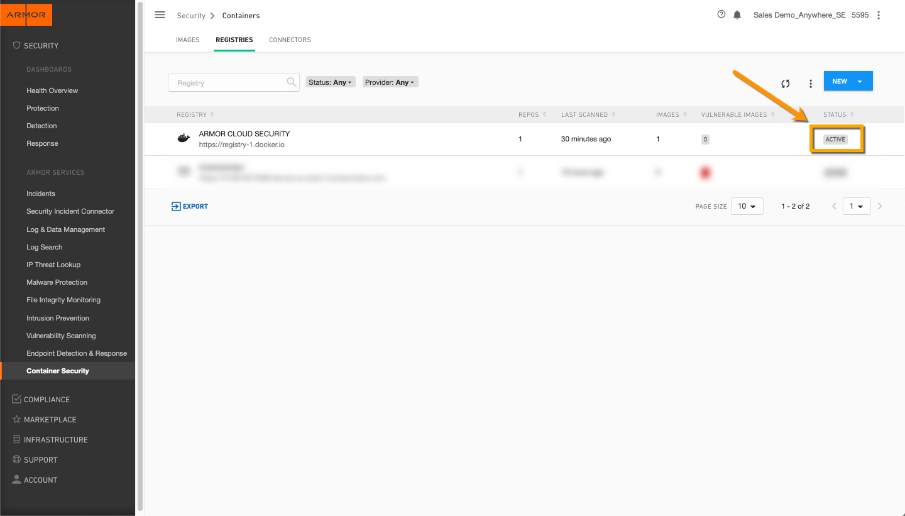

## Step 10 – Download and run a New Sensor.

Select New Sensor to add a sensor container, to your docker host. This is a live running container.

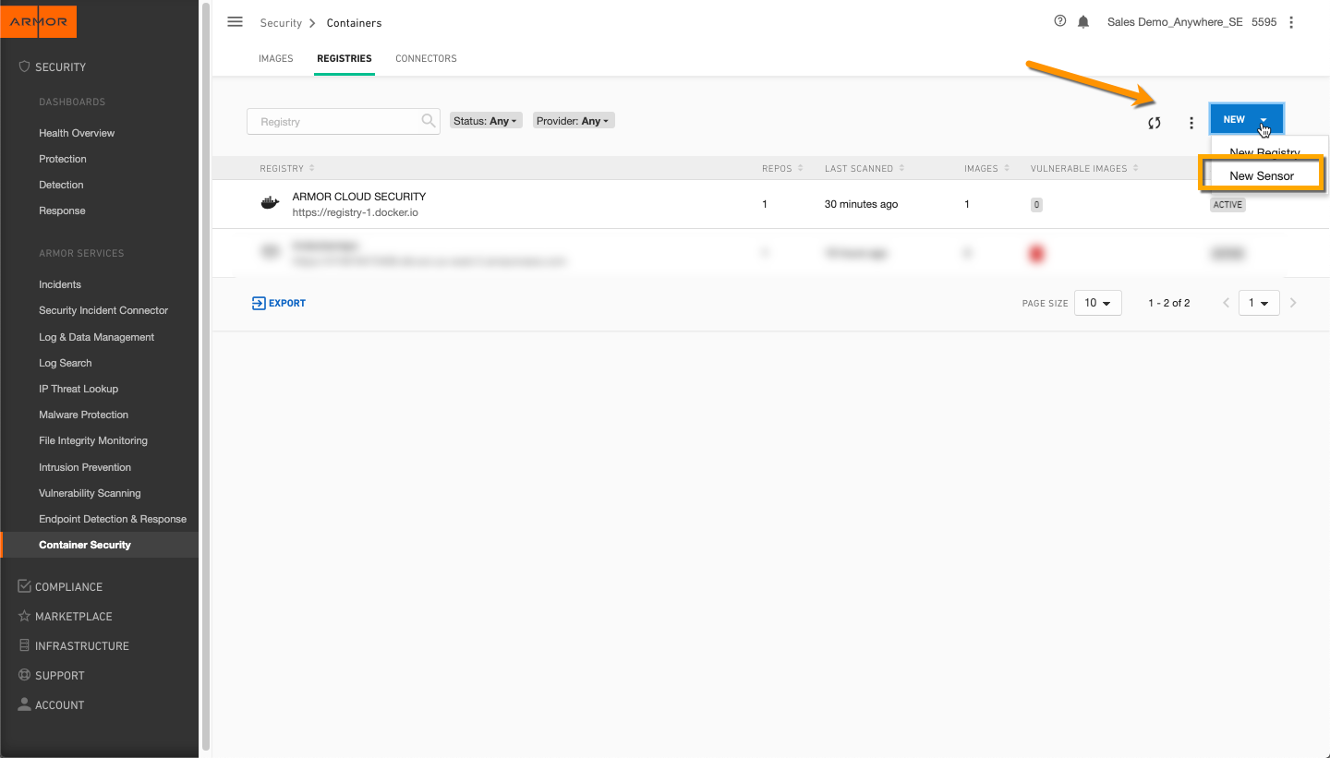

Copy the docker run code.

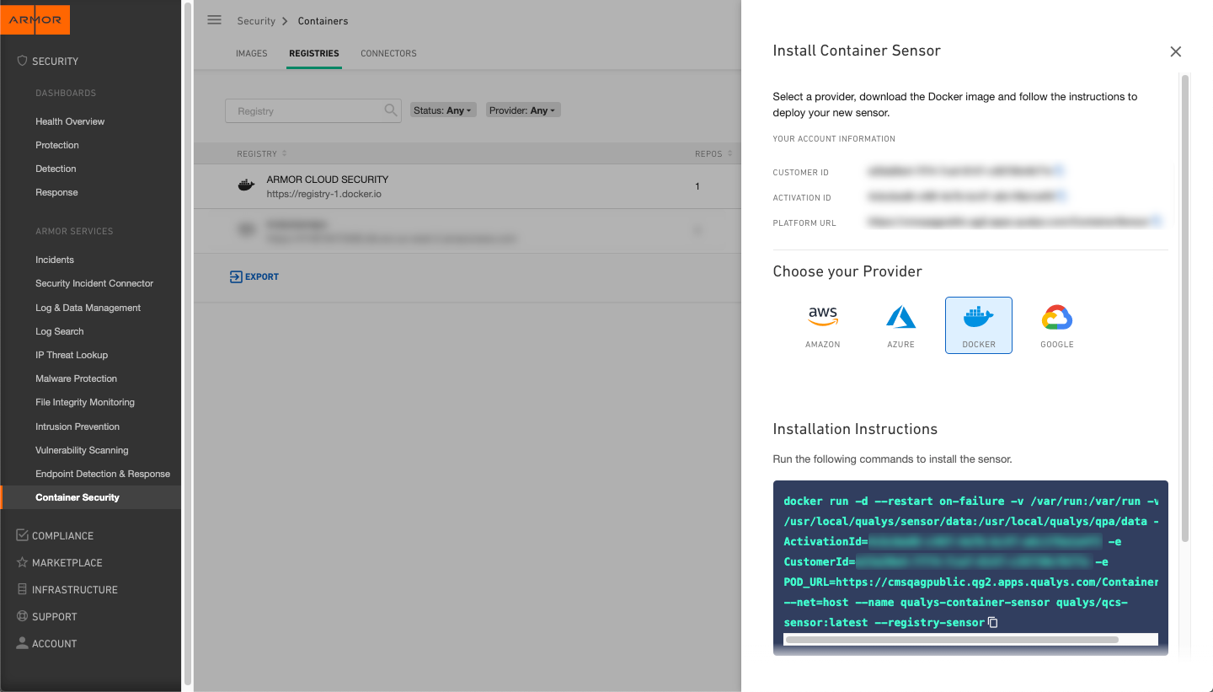

Paste it into your docker host.

Sample **input** / output:

﻿$ **docker run -d --restart on-failure -v /var/run:/var/run -v /usr/local/qualys/sensor/data:/usr/local/qualys/qpa/data -e ActivationId=xxxxxxxx-xxxx-xxxx-xxxx-xxxxxxxxxxxx -e CustomerId=xxxxxxxx-xxxx-xxxx-xxxx-xxxxxxxxxxxx -e POD_URL=https://cmsqagpublic.qg2.apps.qualys.com/ContainerSensor --net=host --name qualys-container-sensor qualys/qcs-sensor:latest --registry-sensor**

﻿﻿Unable to find image 'qualys/qcs-sensor:latest' locally

latest: Pulling from qualys/qcs-sensor

2d473b07cdd5: Pull complete

9dc5cdbbc196: Pull complete

91bf37e2bb1f: Pull complete

091c8b39e626: Pull complete

7bad8ad1ba78: Pull complete

dae8073514dd: Pull complete

343ef8c0f26b: Pull complete

ae1a5f678398: Pull complete

d2dc426e2775: Pull complete

657fccafd5fd: Pull complete

6f08d6bb07e1: Pull complete

c83539a8c928: Pull complete

Digest: sha256:<<xxxxxxx>

Status: Downloaded newer image for qualys/qcs-sensor:latest

<<xxxxxxx>>

$

The container sensor does automatic discovery of Images and Containers on the deployed host, provides a vulnerability analysis of them, and additionally it monitors and reports on the docker related events on the host.

Note: VIRTUALBOX users – The docker run script will not run on a Linux virtual machine Docker Host. You will receive an error message, “﻿docker: Error response from daemon: error while creating mount source path '/usr/local/qualys/sensor/data': mkdir /usr/local/qualys: read-only file system.”

For this you will need to install the sensor manually, please refer to Appendix A of this document.

# Step-by-Step – Remediation

## Step 11 – Vulnerabilities

Log into the Armor Management Portal and navigate to Container Security. Under Images you will see a list of images and color-coded vulnerability columns. Next to the image id, you can select “View Vulnerabilities”.

A list of vulnerabilities will appear.

Clicking on one of the links will list the specific vulnerability found, the related CVE’s and remediation solutions.

# Appendix – A – Installing the ARMOR sensor on a Docker Host, inside a Linux VM in Virtual Box

When you copy the sensor installation script from the Armor Management Portal and try to install it on a Linux VM running in Virtual Box, you will run across a well-known issue that has to do with a read-only portion of the file system.

Note: VIRTUALBOX users – The docker run script will not run on a Linux virtual machine Docker Host. You will receive an error message, “﻿docker: Error response from daemon: error while creating mount source path '/usr/local/qualys/sensor/data': mkdir /usr/local/qualys: read-only file system.”

For this you will need to install the sensor manually, please refer to Appendix A of this document.

There is an easy workaround if you can paste the installation script into a code or text editor, and simply change the /usr directory to /tmp, it will run. Provided there is a /tmp directory available.

## a. Download the sensor

Sample **input** / output:

﻿$ **sudo curl https://get.core.armor.com/containersecurity/QualysContainerSensor.1.7.0-6.us2.tar.xz --output sensor-us2.tar.xz**

﻿ % Total % Received % Xferd Average Speed Time Time Time Current

Dload Upload Total Spent Left Speed

100 103M 100 103M 0 0 62.3M 0 0:00:01 0:00:01 --:--:-- 62.2M

$

## b. Untar the sensor

Sample **input** / output:

﻿$ **sudo tar -xvf sensor-us2.tar.xz**

﻿autoupdate.sh

build-uuid

cssensor-aws-ecs.json

cssensor-containerd-ds.yml

cssensor-crio-ds.yml

cssensor-dcos.json

cssensor-ds_pv_pvc.yml

cssensor-ds.yml

cssensor-openshift-crio-ds.yml

cssensor-openshift-ds.yml

cssensor-swarm-ds.yml

image-id

installsensor.sh

k8s-rolling-update.sh

qualys-sensor-md5

qualys-sensor-sha

qualys-sensor.tar

Sensor_Diagnostic_Script.py

uninstallsensor.sh

version-info

$

## c. Export the environment variable

Sample **input** / output:

﻿$ **export POD_URL=https://cmsqagpublic.qg2.apps.qualys.com/ContainerSensor**

$

## d. Create the directory

Sample **input** / output:

﻿$ **sudo mkdir -p /tmp/local/qualys/sensor/data**

$

## e. Change the permissions

Sample **input** / output:

﻿$ **sudo chmod -R 700 /tmp/local/qualys/**

$

## f. Run the sensor

Sample **input** / output:

﻿$ **sudo ./installsensor.sh ActivationId=xxxxxxxx-xxxx-xxxx-xxxx-xxxxxxxxxxxx CustomerId=xxxxxxxx-xxxx-xxxx-xxxx-xxxxxxxxxxxx Storage=/tmp/local/qualys/sensor/data -s -r**

**﻿**Non-interactive sensor installation

Loading qualys/sensor image...

▓▓▓▓▓▓▓▓▓▓ (done)!

Started 'qualys-container-sensor', container ID: 7afce44b5985 successfully.

For more details, please refer '/tmp/local/qualys/sensor/data/logs/qpa.log' file.

$

# Appendix – B – Useful docker commands

So you don’t have to go searching for them.

Run these commands at your own risk!

## a. login to your docker host

Sample **input** / output:

$ **docker login -–username=<your docker host username>**

**﻿**﻿WARNING! Your password will be stored unencrypted in /root/.docker/config.json.

Configure a credential helper to remove this warning. See

https://docs.docker.com/engine/reference/commandline/login/#credentials-store

Login Succeeded

$

## b. Who are you

Sample **input** / output:

$ **docker info | sed '/Username:/!d;s/.* //'**

**﻿**﻿<your username>

$

## c. List images

Sample **input** / output:

$ **docker images**

﻿REPOSITORY TAG IMAGE ID CREATED SIZE

qualys/qcs-sensor latest 4570fd1fae7c 5 weeks ago 555MB

$

## d. Show all running containers

Sample **input** / output:

$ **docker ps -a**

﻿﻿CONTAINER ID IMAGE COMMAND CREATED STATUS PORTS NAMES

2efd7be05209 qualys/sensor:1.8.1 "/usr/bin/tini -- /u…" 35 minutes ago Up 35 minutes qualys-container-sensor

$

## e. Stop all running containers

Sample **input** / output:

$ **docker stop $(docker ps -a -q)**

-or-

$ **docker exec -it qualys-container-sensor bash**

**$ kill 1**

$

## f. Delete all stopped containers

Sample **input** / output:

$ **docker rm $(docker ps -a -q)**

﻿<container id>

## g. Remove all container images

Sample **input** / output:

$ **docker rmi $(docker images -q) -f**

﻿Deleted:<container id>